I-POP PROJECT
‘Introduction of Points of Care to optimise post-natal prophylaxis for HIV-exposed newborns’
FOR QUALITY CARE FOR CHILDREN TO HIV IN GUINEA

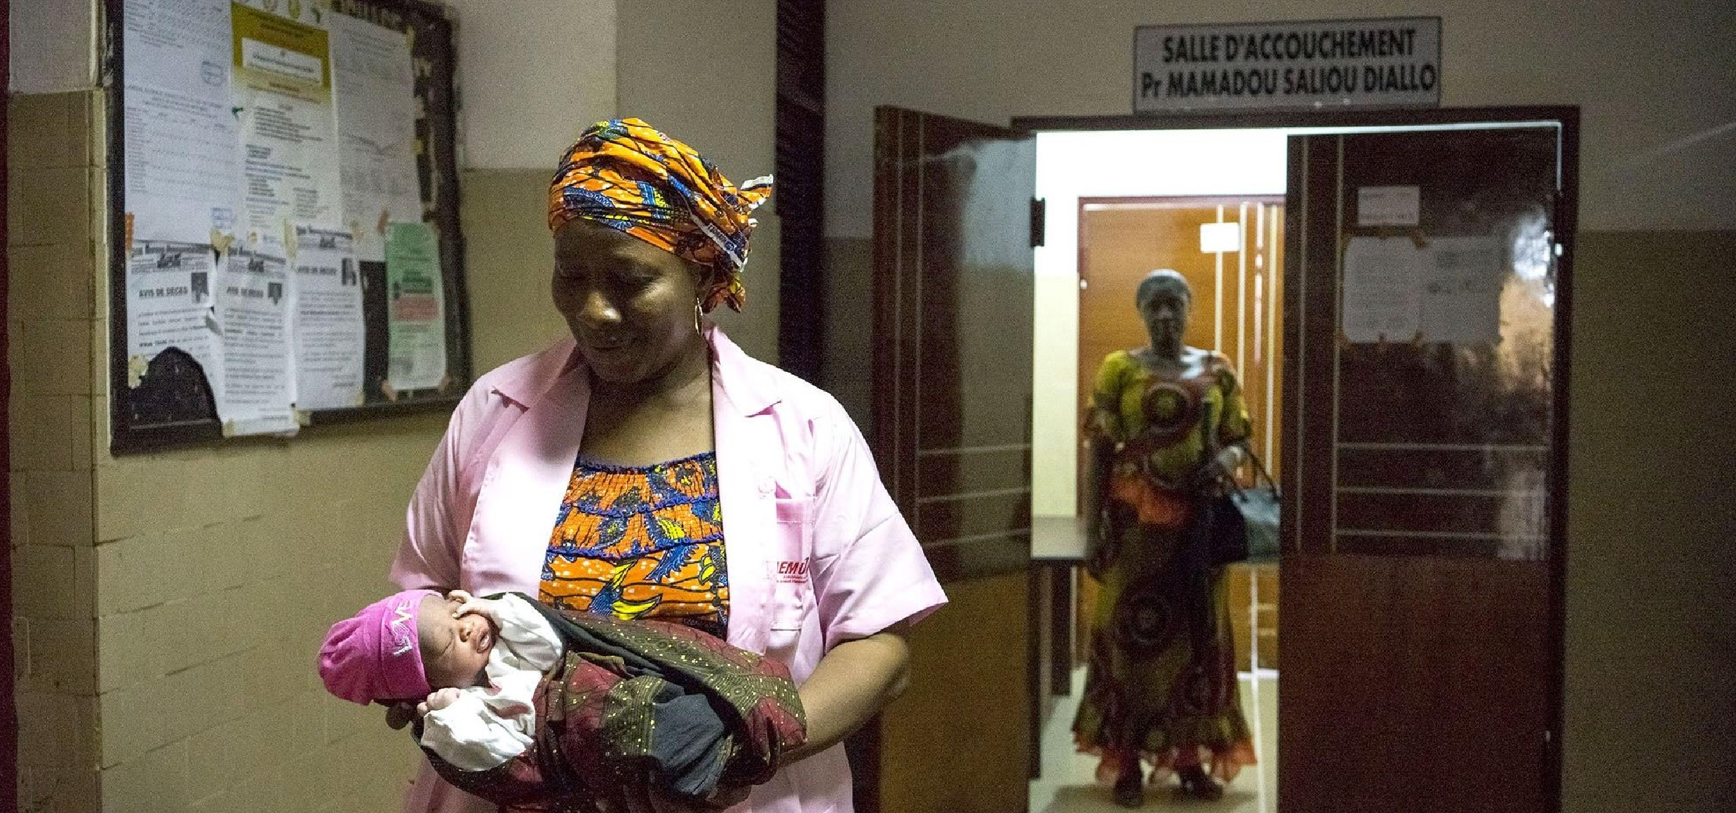
Despite progress in preventing mother-to-child transmission of HIV in recent years, it is estimated that only 37% of pregnant women are currently tested for HIV during pregnancy in Guinea. However, the prevention of mother-to-child transmission of the virus is a crucial issue, as 80% of infected and untreated children are likely to die before the age of 3. In order to address this issue, the IPOP project aims to implement early diagnosis of HIV in HIV-exposed newborns and measurement of the viral load of mothers during delivery, through the implementation of Point of Care (POC) technology. The Point of Care machines allow caregivers to have access to maternal viral load and early infant HIV diagnosis results within 1 hour, in order to immediately optimise preventive treatment for newborns and, if necessary, treatment for the mother.
Solthis ©Loïc Delvaux

/Agence Maps

IPOP PROJECT

KEY INFORMATION
Project duration: 2 years (2021-2023)
Beneficiaries: mother-child pairs affected by HIV/AIDS, maternity and paediatric services, national laboratories
Source of finances: ANRS and the Rotary Club of Conakry and Taipei Fu-Jung and their respective partners
Partners: Fondation Espoir Guinée (FEG), PNLSH (National Programme for the Fight against AIDS and Hepatitis), Ignace Deen Hospital
Country of intervention: Guinea

Project File
O
BJECTIVES

To help reduce the morbidity and mortality of infants born to HIV-infected mothers in Guinea. The IPOP project will evaluate the operationality in Guinea of a strategy combining early diagnosis and systematic preventive treatment of infants from birth (within a maximum of 48 hours after delivery) who are born to HIV-infected mothers who have not received treatment before delivery and/or who are diagnosed as HIV-positive at delivery. This strategy will be implemented through the introduction of Point of Care technology, which also allows for the measurement of viral load in HIV-infected mothers at the time of delivery within 1 hour in order to optimise the preventive treatment of infants according to the estimated risk. 100% of pregnant women who benefit from a viral load measurement will be put on the appropriate treatment for themselves and their infants.

The project is a continuation of the ANRS 12344 DIAVINA research project (2017-2019), which led to the first demonstration at Ignace Deen Hospital of the feasibility of a strategy combining reinforced preventive treatment and diagnosis at birth to reduce the risk of infection in newborns. The project has led to increased screening and management of mothers and their infants.
PROJET IPOP

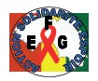
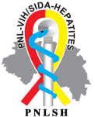
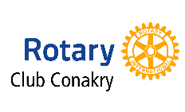
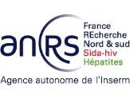
EXPECTED RESULTS
- HIV testing of all women admitted for delivery at Ignace Deen Hospital: about 6000 women;
- Putting all women who test positive on appropriate medication to protect them and their babies;
- Early screening of all infants born to infected mothers and routine life-saving treatment depending on the assessed risk of transmission.
The project will improve the Guinean health system by strengthening the capacity of health personnel to systematically implement HIV screening in the labour ward, early infant diagnosis, and differentiated treatment of newborns .... The lessons learned from the project will be made available to the national authorities to improve the national strategy to combat mother-to-child transmission of HIV in Guinea.

